Technical Difficulties Overcome

## Email Server

We had technical difficulties with the identity folders on the left panel, which had a limit of 50 different automatic filters to sort incoming emails with, so not all emails are properly routed to their corresponding identity folders. We attempted to set up a custom script using Sieve, an email filtering scripting language. It was supposed to separate emails into individual folders based on recipient address. This failed because the scripting language was case sensitive so lowercase letters would cause a recipient's email to get filtered to a brand new folder. Also, sometimes it would not filter emails and just kick them to the Inbox. There are still a ton of emails in the existing folders so do not forget these. Good luck if you want to try and fix the filter script, RainLoop was unresponsive to support tickets/emails.

## Virtual Phone Numbers

We discovered that some of the 150 virtual Zadarma numbers had been used previously to make throw-away accounts, which were recognized on certain sites, and prevented account creation (some websites more so than others). Since we had so many to choose from, we could just keep trying different numbers until one worked -- early on, we would sometimes get lucky and find one, but after roughly ⅔ of the numbers had been assigned, our odds decreased dramatically (naturally, since the pool to choose from was much smaller).

For example, with YouTube/Google, I tried every single unclaimed number from the list for SMS verification (43 at the time), all of which were rejected with an error message ____ , rendering it impossible to create any new accounts.However, that should be expected, since we were essentially “renting” virtual access to the phone numbers through Zadarma, on a monthly basis, so there could have potentially been hundreds of former users “renting” them before us.

## VPN Protection

We should have been more careful about over-using a VPN connection to switch public IP addresses too quickly, **\**especially\**** while accessing the same account’s website, because certain websites (i.e. Google, Facebook, Amazon) seem to flag “suspicious” patterns in IP logs, and respond with various levels of severity *(Figure 1)*.

Thus, in the future we should try to limit both the frequency and duration of logged-in browsing sessions, if possible, to minimize how many distinct VPN node IP addresses are associated with any given Fake Identity.

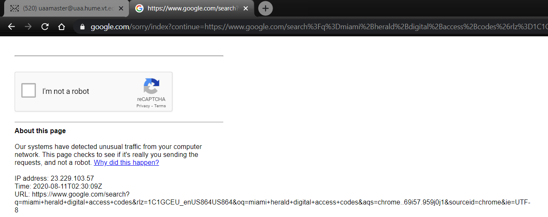

*(Figure 1 - Oops. Got Caught VPN Speeding)*

## Identity Creation

The most frustrating technical problems we encountered were with facebook. We were initially able to create 2 facebook accounts without issue, but after July 30th, all new accounts we tried to make were instantly disabled upon creation *(Figure 2)*.

We couldn’t pinpoint exactly what was being flagged, but some combination of our unorthodox email domain name, usage of questionable Zadarma numbers, VPN usage, 2020 election pressure, and our poorly-thought-through default password “Fakeidentity123” must have given us away as ne'er do-wells.

But also, *\*manually disabling\** Enhanced Protection from Fingerprinter scripts, \**(which collect settings from your browser and computer to create a unique profile to track you across different websites)*\* probably didn't help our anonymity… *(“a significant oversight on my behalf…” -- Josh)*

Facebook allows you to submit 1 single Review Request to appeal the ban, which requires a valid *(unused)* phone number for SMS verification, then requests you “Upload a Photo of Yourself” *(we used thispersondoesnotexist.com to generate an image)*. Upon completion of this appeal, the same message is shown every time you try to log into your account (Figure 3), indefinitely, until a human theoretically has time to review it. We recently checked back on our still-disabled facebook accounts, and discovered a status update -- that someone finally did review our appeals, but rejected them -- so our newly-created accounts are now permanently disabled *(Figure 4)*.

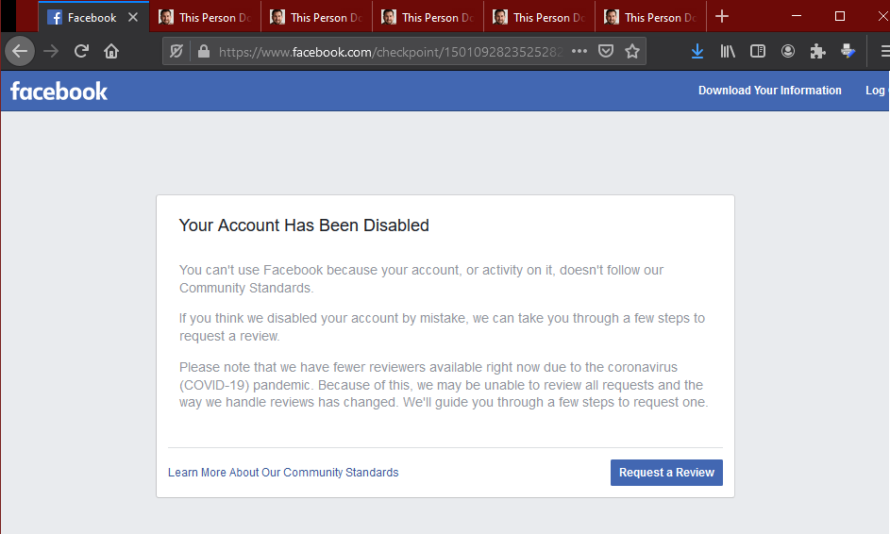

*(Figure 2 - Account Disabled Upon Creation)*

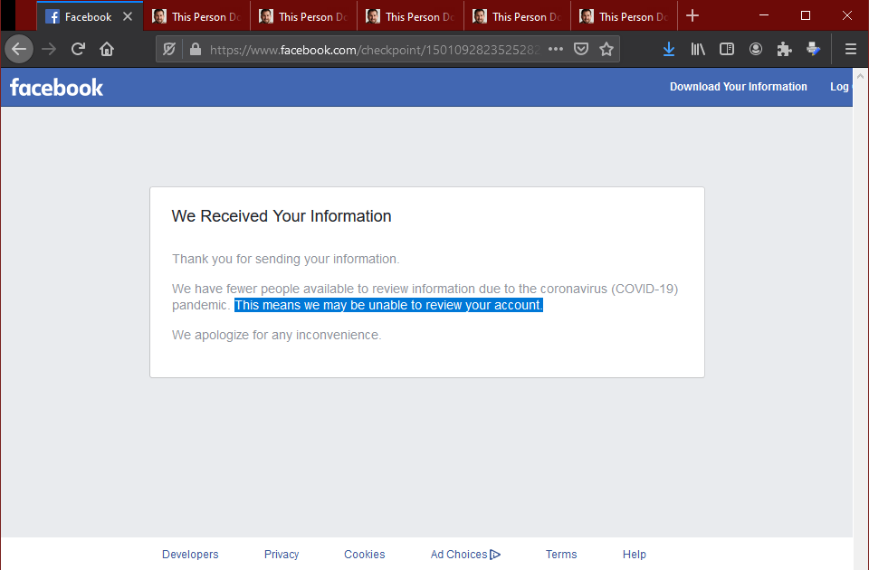*(Figure 3 - Locked Account Status)*

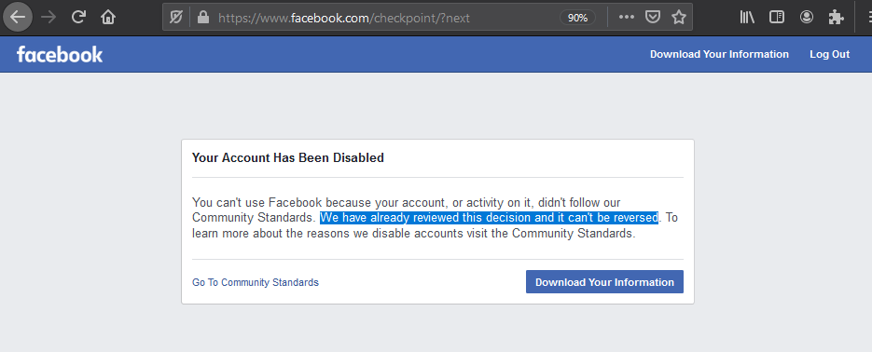

*(Figure 4 - Perma-Banned Status)*

## Domestic Account Creation

TikTok and Google were able to detect some of the numbers as fraudulent and instantly disallowed them for the creation of the account.

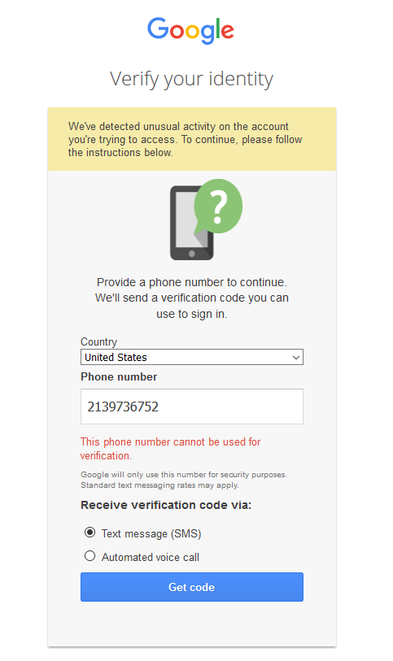

Without the mobile app, Tiktok creation was slightly difficult - however, some numbers passed the initial verification process. The numbers we bought from Zadarma were used before so could have been previously flagged, and it is indeterminate why some were flagged while others weren't (specific theories presented above). Google, in particular, was consistent with denying the Zadarma verification phone numbers.

## International Account Creation

The international profiles posed multiple barriers. Some websites, which have been previously researched, have changed names/owners making it harder to find specific websites. Others had obvious language barriers that made it time consuming as we had to manually translate each page of the sign up process. Even then, some sites would not allow foreign phone numbers or emails to be processed. Sometimes the websites would allow the initial transaction to be completed - but we would not receive any confirmation emails/phone calls, initiating a state of radio silence with the transaction site.

Finally, most of the Asian transaction sites required the use of a cell phone to interact with the app. Websites like this included QQ, Qzone, Tencent Video, WeChat, Toutaio etc. This wasn’t possible, so additional research was needed to find transaction ready sites. Overall the international account-making process presented significantly more challenges than domestic sites.